# 4. Scope Management Plan

## Project:

## Scope Management Approach

Scope Management Plan in which it addresses the following:

* Who has authority and responsibility for scope management
* How the scope is defined (i.e. Scope Statement, WBS, WBS Dictionary, Statement of Work, etc.)
* How the scope is measured and verified (i.e. Quality Checklists, Scope Baseline, Work Performance Measurements, etc.)
* The scope change process (who initiates, who authorizes, etc.)
* Who is responsible for accepting the final project deliverable and approves acceptance of project scope

For this project, scope management will be the sole responsibility of the Project Manager. The scope for this project is defined by the Scope Statement, Work Breakdown Structure (WBS) and WBS Dictionary. The Project Manager, Sponsor and Stakeholders will establish and approve documentation for measuring project scope which includes deliverable quality checklists and work performance measurements. Proposed scope changes may be initiated by the Project Manager, Stakeholders or any member of the project team. All change requests will be submitted to the Project Manager who will then evaluate the requested scope change. Upon acceptance of the scope change request the Project Manager will submit the scope change request to the Change Control Board and Project Sponsor for acceptance. Upon approval of scope changes by the Change Control Board and Project Sponsor the Project Manager will update all project documents and communicate the scope change to all stakeholders. Based on feedback and input from the Project Manager and Stakeholders, the Project Sponsor is responsible for the acceptance of the final project deliverables and project scope.

## Roles and Responsibilities

| Name | Role | Responsibilities |
| --- | --- | --- |
| John Doe | Sponsor | Approve or deny scope change requests as appropriate Evaluate need for scope change requests Accept project deliverables |
| Jane Doe | Project Manager | - Measure and verify project scope - Facilitate scope change requests - Facilitate impact assessments of scope change requests - Organize and facilitate scheduled change control meetings - Communicate outcomes of scope change requests - Update project documents upon approval of all scope changes |
| Bob Jones | Team Lead | - Measure and verify project scope - Validate scope change requests - Participate in impact assessments of scope change requests - Communicate outcomes of scope change requests to team - Facilitate team level change review process |
| John Smith | Team Member | - Participate in defining change resolutions - Evaluate the need for scope changes and communicate them to the project manager as necessary |
| Tom Brown | Team Member | - Participate in defining change resolutions - Evaluate the need for scope changes and communicate them to the project manager as necessary |

Table 1.1, Scope Management Roles and Responsibilities

## Scope Definition

The scope definition section details the process of developing a detailed description of the project and its deliverables. This can only be completed after the requirements have been identified and defined during the requirements definition process. During the requirements definition process three documents were created; Requirements Documentation, Requirements Management Plan and a Requirements Traceability Matrix. You can refer to these documents when defining the projects’ scope.

This section of the Scope Management Plan should explain the process you followed to develop the detailed description of the project and its deliverables. If you used other documents such as the Project Charter, Preliminary Project Scope Statement or Requirements Documentation you should identify them and all other documents used. You should tie the scope definition process back to the requirements definition as the project’s scope answers the requirements for the project.

You should also document the tools and techniques used to define the project scope such as expert judgment, product analysis, alternatives identification or facilitated workshops.

The scope for this project was defined through a comprehensive requirements collection process. First, a thorough analysis was performed on the company’s current software applications based on employee and user feedback. From this information, the project team developed the project requirements documentation, the requirements management plan, and the requirements traceability matrix for what the new software application must accomplish.

The project description and deliverables were developed based on the requirements collection process and input from subject matter experts in software design, technical support, programming and business applications. This process of expert judgment provided feedback on the most effective ways to meet the original requirements of providing a new software platform from which the company can improve its financial tracking and internal financial processes.

## Project Scope Statement

The project scope statement details the project’s deliverables and the work necessary to create these deliverables. The Project Scope Statement should contain the following components:

Product Scope Description – describes what the project will accomplish

Product Acceptance Criteria – describes what requirements must be met in order for the project to be accepted as complete

Project Deliverables – a detailed list of deliverables the project will result in

Project Exclusions – description of work that is not included in the project and outside of the scope. What work should not be performed in order to eliminate any implied but unnecessary work which falls outside of the project’s scope.

Project Constraints – lists limits on resources for time, money, manpower, or equipment (capital)

Project Assumptions – describes the list of assumptions the project team and stakeholders are working under to complete the project

This project includes the design, programming, and testing of a new software application for tracking the company’s finances. The deliverables for this project are a completed software application for finance tracking with the flexibility to modify and expand the application as necessary in the future. This project will be accepted once the new software has been successfully tested in each department and has been shown to be compatible with the company’s current information technology (IT) infrastructure. This project does not include ongoing operations and maintenance of the software. Only internal personnel and resources may be used for this project. Additionally, the project is not to exceed 180 days in duration or $450,000 in spending. Assumptions for this project are that support will be provided by the project sponsor and all department managers and that adequate internal resources are available for the successful completion of this project.

## Work Breakdown Structure

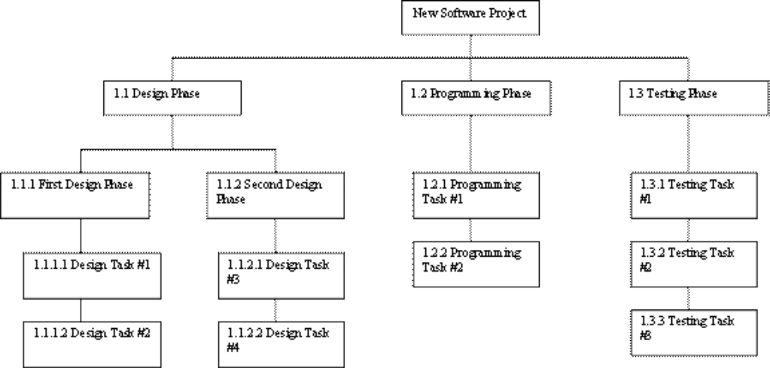

In order to more clearly define the work necessary for project completion the WBS Dictionary is used. The WBS Dictionary includes an entry for each WBS element. The WBS Dictionary includes a detailed description of work for each element and the deliverables, budget and resource needs for that element. The project team will use the WBS Dictionary as a statement of work for each WBS element.

| Level | WBS Code | Element Name | Description of Work | Deliverables | Budget | Resources |
| --- | --- | --- | --- | --- | --- | --- |
|  |  |  |  |  |  |  |
|  |  |  |  |  |  |  |
|  |  |  |  |  |  |  |

Table 1.2, WBS Dictionary

## Scope Verification

The scope verification discusses how the deliverables will be verified against the original scope and how the deliverables from the project will be formally accepted. The deliverables for the project should be formally accepted and signed off on by the customer throughout the lifecycle of the project and not held back as a single deliverable at the end of the project.

As this project progresses the Project Manager will verify interim project deliverables against the original scope as defined in the scope statement, WBS and WBS Dictionary. Once the Project Manager verifies that the scope meets the requirements defined in the project plan, the Project Manager and Sponsor will meet for formal acceptance of the deliverable. During this meeting the Project Manager will present the deliverable to the Project Sponsor for formal acceptance. The Project Sponsor will accept the deliverable by signing a project deliverable acceptance document. This will ensure that project work remains within the scope of the project on a consistent basis throughout the life of the project.

## Scope Control

The Project Manager and the project team will work together to control of the scope of the project. The project team will leverage the WBS Dictionary by using it as a statement of work for each WBS element. The project team will ensure that they perform only the work described in the WBS dictionary and generate the defined deliverables for each WBS element. The Project Manager will oversee the project team and the progression of the project to ensure that this scope control process if followed.

If a change to the project scope is needed the process for recommending changes to the scope of the project must be carried out. Any project team member or sponsor can request changes to the project scope. All change requests must be submitted to the Project Manager in the form of a project change request document. The Project Manager will then review the suggested change to the scope of the project. The Project Manager will then either deny the change request if it does not apply to the intent of the project or convene a change control meeting between the project team and Sponsor to review the change request further and perform an impact assessment of the change. If the change request receives initial approval by the Project Manager and Sponsor, the Project Manager will then formally submit the change request to the Change Control Board. If the Change Control Board approves the scope change the Project Sponsor will then formally accept the change by signing the project change control document. Upon acceptance of the scope change by the Change Control Board and Project Sponsor the Project Manager will update all project documents and communicate the scope change to all project team members and stakeholders.